**NON-GEO 5GCBH**

**Final Report**

**ESTEC Contract Number PO4000132892**

**ESA Technical Officer(s): Georgios Ziaragkas, ECSAT, Harwell**

**ST Engineering iDirect (Europe),**

**Sint-Niklaas, Belgium**

EUROPEAN SPACE AGENCY

CONTRACT REPORT

The work described in this report was done under ESA contract. Responsibility for the contents resides in the author or organisation that prepared it.

**Date: 16/12/2021**

**Document ref. no.** WP5000-4  
NON-GEO 5GCBH Final Report

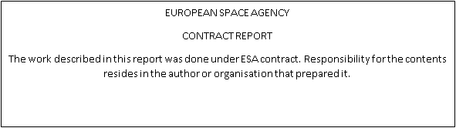

**ABSTRACT**

The NON-GEO 5GCBH technology project explores and de risks 3 major technology domains related to multi-orbit ground segment Satcom systems:

* Seamless satellite handover mechanisms in constellations
* Flexible Payload interaction with ground segment
* Service orchestrated interaction with terrestrial networks

This final report describes the findings of this ESA ARTES Technology phase project.

**Contents**

1 Introduction 4

2 About ST Engineering iDirect (Europe) 5

3 Objectives 6

4 Perspective 13

5 Abbreviations 17

6 References 19

# Introduction

ST Engineering iDirect (Europe) has within its strategic R&D roadmap expressed the ambition to become global player within the non-geo satellite constellation markets. Key focus of our company remains on the ground segment infrastructure for satellite communication. This is an important part of our “New Ground” vision (see 4.1).

This project is an important first step in the realization of this strategy.

The NON-GEO 5GCBH technology project explores and de risks 3 major technology domains related to multi-orbit ground segment Satcom systems:

* Seamless satellite handover mechanisms in constellations
* Flexible Payload interaction with ground segment
* Service orchestrated interaction with terrestrial networks

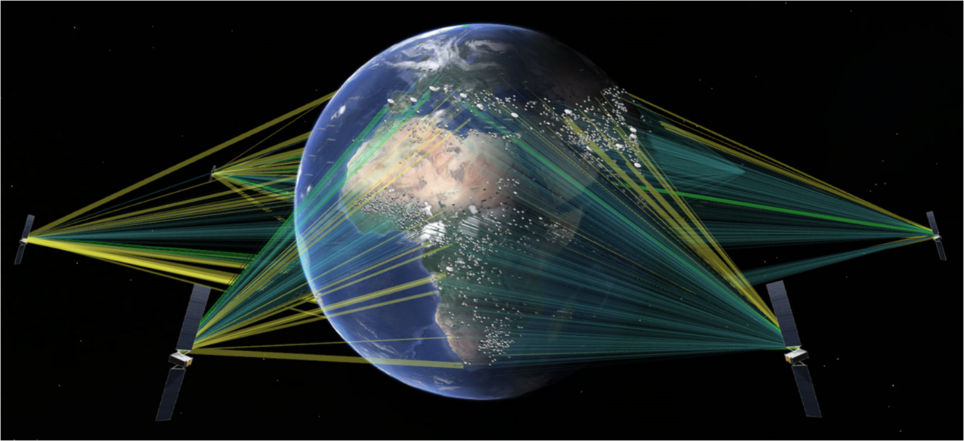

Figure 1 Non GEO constellations

# About ST Engineering iDirect (Europe)

ST Engineering iDirect is a global leader in IP-based satellite communications. We provide technology and solutions to enable our service provider and satellite operator partners to optimize their networks, differentiate their services and profitably expand their business.

ST Engineering iDirect (Europe) is based in Belgium; the research and engineering department holds over 100 skilled engineers – furthermore the Erpe-Mere based Manufacturing Competence Centre provides production facilities.

(https://www.idirect.net/st-engineering-idirect-europe/)

# Objectives

The NON-GEO 5GCBH technology project explores and de risks three major technology domains related to multi-orbit ground segment Satcom systems:

* Seamless satellite handover mechanisms in constellations
* Flexible Payload interaction with ground segment
* Service orchestrated interaction with terrestrial networks

The project objective is to advance the TRL from 2-3 to level 5 of these key technologies through focused Proof of Concepts and as such prepare for full multi-orbit ground segment system development.

This technology project successfully achieved the objective as stated above; some findings will be addressed further within the subsequent ESA ARTES PRODUCT phase project “ COSMOS”. For instance, the further handling of potential packet reordering and minimal packet loss during satellite hand-overs for higher throughputs will be tackled within the Product Phase.

## Description of the resulting Technologies

The starting point of this project was the known technology of a VSAT system operating on a GEO satellite. A number of technologies will remain very similar when making the step towards NON-GEO constellations. These areas are marked in green in figure 2. However, there are three key areas of technology that are NEW when introducing NGEO constellations and more dynamic allocation of space capacity.

There areas are (marked in red in figure 2):

* Seamless satellite handover mechanisms in constellations
* Flexible Payload interaction with ground segment
* Service orchestrated interaction with terrestrial networks

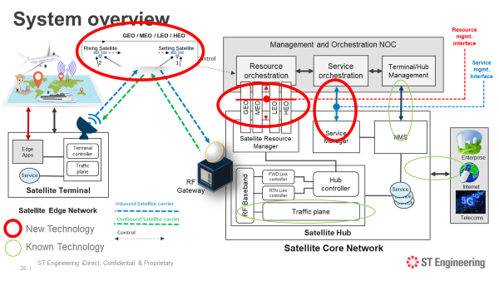

Figure 2 Domains of New Technology

In the next sections, we will zoom in on each technology domain and provide next to a description also the major challenges faced and resulting outcome. Finally, the key benefits of this technology will be highlighted.

## Seamless satellite handover mechanisms in constellations

### Description

During normal operation a specific channel/beam is served by only one satellite.

For the purpose of handover, a channel/beam will be served during a limited period by two satellites (the rising and the setting satellite).

Note that timings are different in the various LEO & MEO constellations.

As example, MEO targets a duration of 30 seconds for this handover period, during which a channel/beam is covered by two satellites. This in order to use satellite resources as efficiently as possible, by avoiding double capacity allocation on two satellites over prolonged periods.

Note that the beams are only 100km in diameter, and both satellites (rising and setting) will be visible for all terminals within that beam for a much longer time. This means terminals can perform handover almost simultaneously. During this 30 second period the gateway should also provide connectivity via the two satellites.

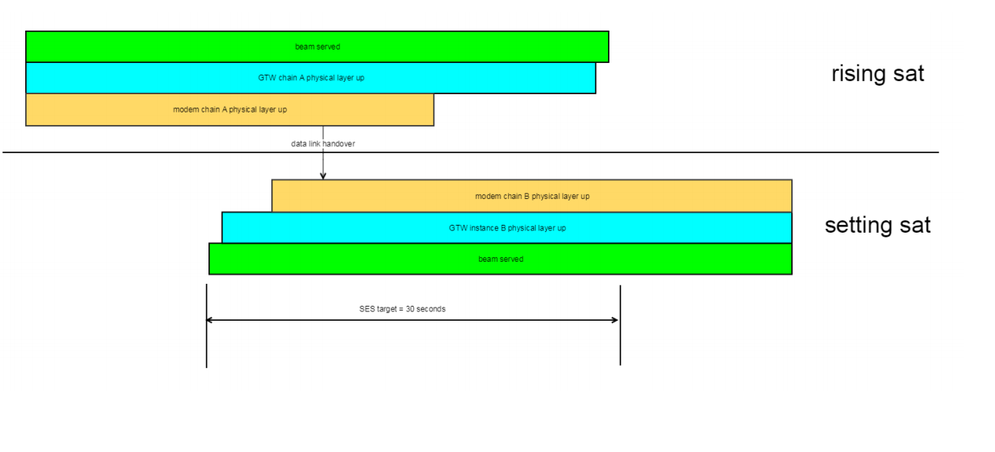At satellite handover, the intention can be to use this handover opportunity for reallocating satellite bandwidth. In this case, the handover plan will change every time bandwidth is reallocated. Such opportunity will occur every 51 minutes. In the following example SAT 1 is the setting satellite of channel 1 and SAT 2 is the rising satellite of channel 1. A 'channel' corresponds to a to a service offered in a specific coverage area or beam. In Dialog terminology we can map a channel to a satnet and beam.

Figure 3 Interworking with External Payload and GS controller

Note that the correct ST Engineering iDirect definition of satnet is an association of a forward link and return. During handover the channel/beam is served simultaneously by the two satellites SAT 1 and SAT 2. In the gateway two antennas are used for seamless handover between satellites. This requires two 'segment 1 +2 HPS' instances of the Dialog hub for a satnet at the time of handover. As not all beams are handed over simultaneously, it is not needed to have two' segment 1 +2 HPS' instances per satnet instantaneously.

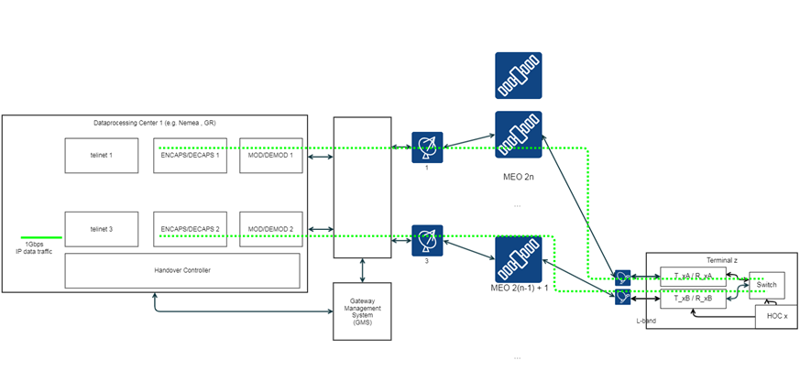

Figure 4 Satellite hand-over: Active and Standby flows with the Hub and terminal

### Challenges encountered

Next to designing the active and standby chain at the hub site, the key challenges were in designing and developing the testbed environment in which this technology can be correctly validated. Also, the redesign of the modem/terminal in order to able to receive and handle 2 active connections was new and an additional challenge.

Finally, verifying and optimizing the end-to-end Make- before- break technology in various traffic throughput conditions has proven to be the key challenge.

### Resulting outcome

A successful Proof of Concept of the Make before break handover was conducted and demonstrated including:

* Hub prototyping of active and hand-over satnet architecture and its functional capability
* Modem and terminal Make before Break (MBB) prototyping

Note that the further handling of potential packet reordering and minimal packet loss during satellite hand-overs for higher throughputs will be tackled within the Product Phase.

### Key Benefits

The technology of “Seamless satellite handover mechanisms in constellations” is   
resulting in seamless, packet loss free data services operating in NGEO constellations.

## Flexible Payload interaction with ground segment

### Description

This topic has researched and de risked the impact of interaction and interworking with flexible payloads and the related control plane interactions which will steer both the Payload configurations (beam forming, power, beams) as well as the Ground segment in an automated and timely synchronized manner.

This activity performed the following work items:

* Study and alignment on interaction between External scheduler and the VSAT platform
* Research and definition on modelling of the resources (GS, Payload) such that the model clearly reflects the capabilities but as well the restriction of these components.
* Alignment on type of interface, interface message and content, response and interaction time
* PoC of early integration of External scheduler and VSAT system API
* 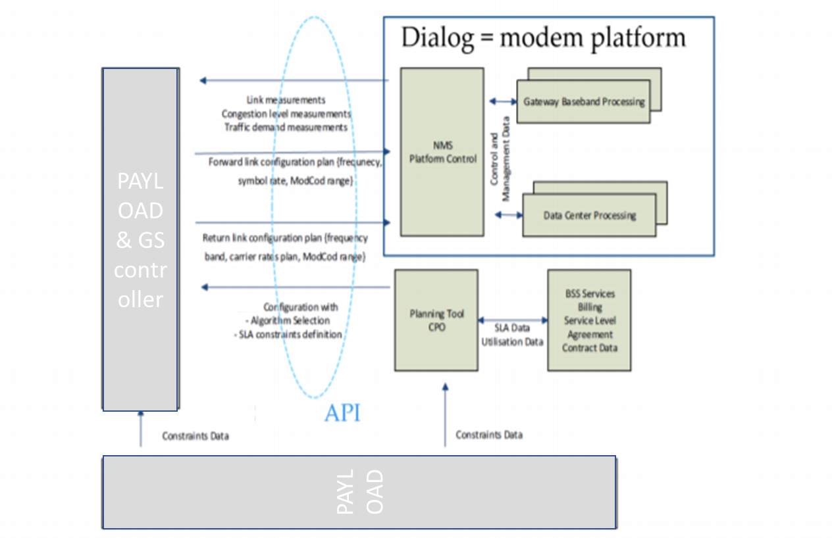Test bed integration of the involved functional blocks   
  The figure below is showing the studied interactions that are typically required between an external scheduler and the Newtec Dialog Ground Segment. The external scheduler needs to be interacting with the flexible configurable payloads also.

Figure 5 - LSO high level reference architecture diagram courtesy of MEF

### Challenges encountered

The key challenge for this technology was to define a workable interface between the dynamic payload and the ground segment, to identify all the important parameters and related time information that requires synchronization between the flexible satellite payload and the ground segment.

Second challenge was to construct within the ground segment an underlying data model that supports these dynamic parameter changes. Also designing the timely internal flow of the control information to key components in the Hub (Modulator, Demodulators) as well as to the remote terminal was key.

### Resulting outcome

The successfully conducted Proof of Concept indicate the feasibility of this technology and interface between Payload and VSAT ground segment. The interface and key parameters have been identified.

### Key Benefits

The technology of “Flexible Payload interaction with ground segment” is   
resulting in a dynamic and flexible satellite capacity allocation driven by service and traffic demand.

## Service orchestrated interaction with terrestrial networks

### description

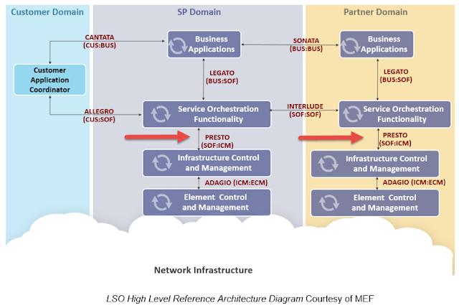This activity performed a Proof of Concept on the L2 MEF-like Service Orchestration and related interfaces in line with 5G & MEF architectures and scalable architectures

Figure 6 MEF model with PRESTO interface

* + Follow activities have been performed within this workstream:
    - PoC of interfacing model between the Service Layer Orchestration Functionality towards the Infrastructure Control and Management (So-called PRESTO interface)
    - Within the satellite ground segment, the Network infrastructure orchestration and deployment will be triggered by these service orchestration requests – the flexibility and dynamicity has been defined and tested defined and tested.

### Challenges encountered

Main challenge here was to build up know-how and find the best suited practices in implementing a Service orchestrated interaction taking into account the ongoing standardization on MEF.

### Resulting outcome

A successful Proof of concept was conducted illustrative the feasibility of the service orchestration interaction based on the PRESTO-MEF interface using the PRESTO SDK.

### Key Benefits

Service orchestrated interaction with terrestrial networks resulting in an automated integrated of E2E (terrestrial, satellite) of data services in accordance with standardization (MEF)

# Perspective

The perspective of the outcomes of this Technology project is multifold:

* By successful de risking of the key technology, it opens the door for full ground segment system development. This has started within the scope of the ESA ARTES COSMOS “ **Co**mmunication **S**ystem for **M**ulti **O**rbit ground **S**egment” project.
* Further rolling out of “New Ground” vision of ST Engineering iDirect enhanced with the outcomes of this technology project. (see 4.1)
* Building out the Satellite communication ground segment of the SES MPower MEO constellation as a first important business realization using the outcomes of this technology project. (see 4.2)

## New Space – New Ground

The NON-GEO 5GCBH project is a first step in the realization of the ST Engineering iDirect “NEW GROUND” strategy. (figure 7)

Within the ecosystem convergence, there are three large areas of technology transition:

* 5G technology headed by the Global Telco and IT world
* Cloud technology, headed by the large global platform players and IT
* New Space, headed by Space Industry and some innovative newcomers

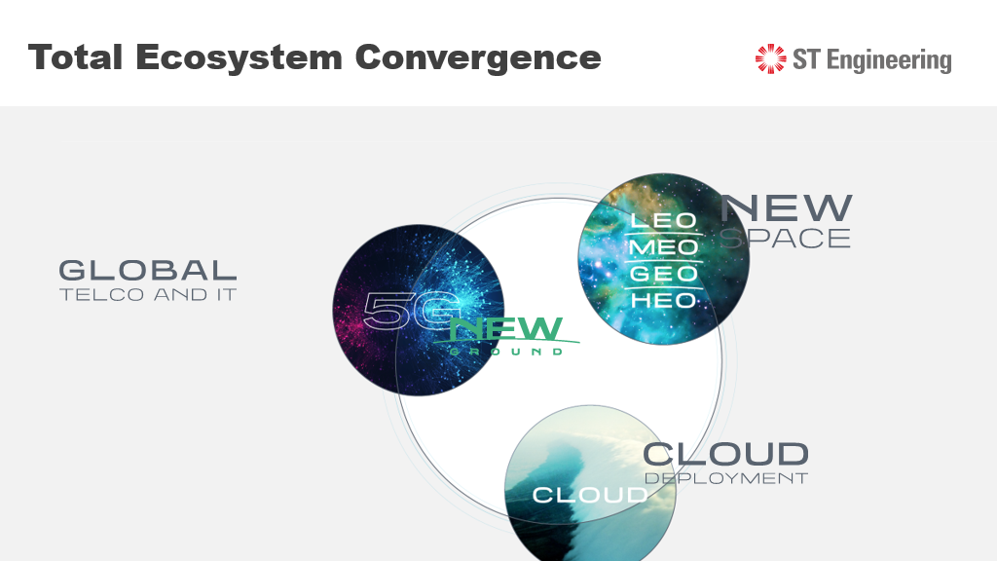

Figure 7 Total ECO System convergence

The convergence point of all these areas is concentrated mainly on the (Satellite) Ground Segment; this is pivotal between these areas. With the “New Ground” strategy of ST Engineering iDirect the goal is to glue these domains in a flexible and dynamic manner such that they create substantial value to integrated services running on top of them on to the global and regional operators.(figure 8)

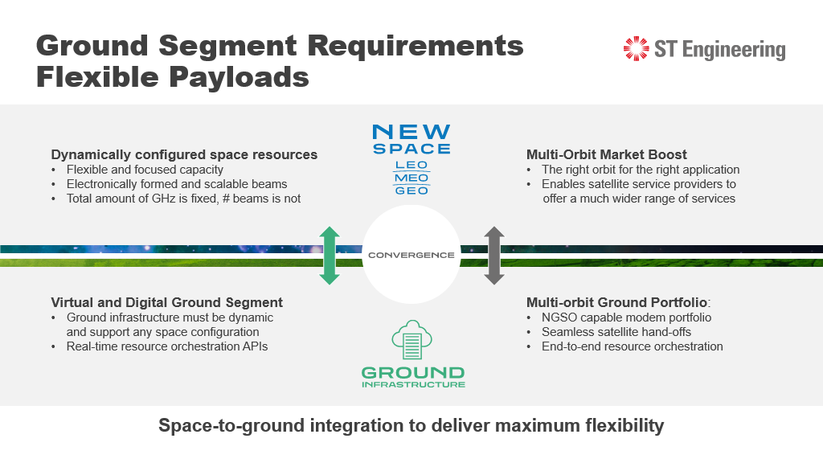

Figure 8 Space -to -ground integration

ST Engineering iDirect is informing and providing “thought leadership” in relation to the “New Ground” outlooks and opportunities. Various webinars have been organized for this purpose:

* <https://www.idirect.net/2020/11/19/breaking-new-ground/>
* <https://www.satellitetoday.com/content-collection/seeking-new-ground-for-new-space/>
* https://www.bigmarker.com/access-intelligence-llc1/How-To-Navigate-The-Next-Generation-Ground-Technology-Journey?show_live_page=true

## MPower opportunity

Next to this, ST Engineering iDirect (Europe) also contracted with SES for the major MPOWER business opportunity as described below.

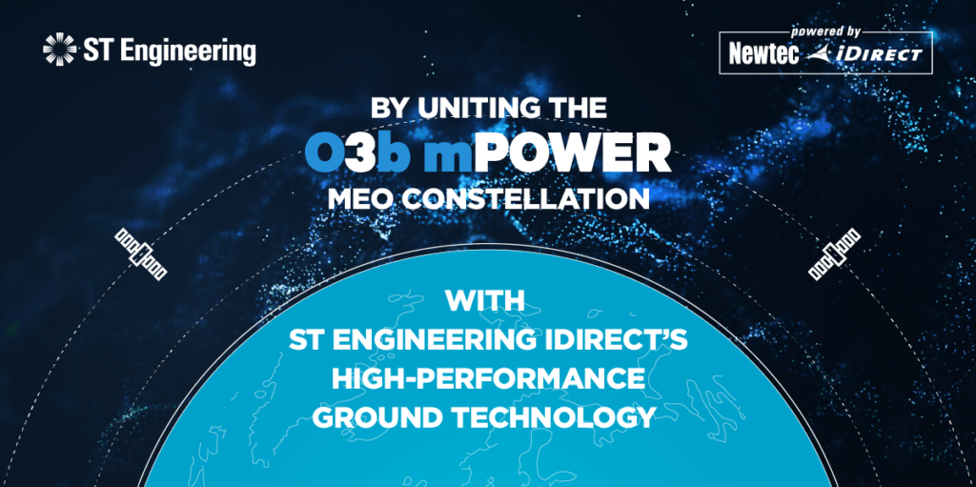

ST Engineering iDirect, a global leader in satellite communications, has announced that it will provide its high-performance ground infrastructure for O3b mPOWER, [SES](https://o3bmpower.ses.com/newsroom)’s next-generation Medium Earth Orbit (MEO) communications system. Pairing ST Engineering iDirect’s breakthrough ground technology with spacecraft innovations, O3b mPOWER will enable a flexible, low-latency, high-speed, fiber-like experience for industry segments that include telcommunications/Mobile Network Operator, government, aerospace, cruise, offshore energy, mining and commercial shipping.

The O3b mPOWER system is a critical innovation milestone for the satellite industry. ST Engineering iDirect’s high-performance ground technology is key to optimizing the end-to-end capabilities of the MEO constellation for delivery of highly efficient networks with highly reliable services.

The integration of SES and ST Engineering iDirect technologies results in a powerful feature set, including:

Space-to-ground integration to deliver maximum flexibility: ST Engineering iDirect’s dynamic ground system, combined with SES’s O3b mPOWER satellites and the differentiated resource management capability of Adaptive Resource Control (ARC), enables the dynamic control and optimization of power, throughput, beams and frequency allocation across the entire system, resulting in the efficient delivery of low-latency, satellite-based data services with a superior end-user experience.

Unprecedented scalability and dynamic allocation of resources: Facilitated through the highly flexible, virtualized hub and baseband that can independently scale gigahertz, gigabits, and number of carriers.

End-to-end service orchestration and automation: Seamless integration into overall satellite and terrestrial hybrid networks based on open architectures and standardized platform APIs reduces operational complexities and ensures that services are implemented in an automated, expedient and seamless manner as needed.

Proven DVB-S2X and award-winning Mx-DMA waveforms: Highly optimized for throughput, efficiency and availability on both the forward and return channels to enable carrier-grade performance previously only achievable over fiber networks, scalable up to multiple gigabits-per-second for fixed and mobility applications.

Powerful terminal portfolio for every market and application: The existing MDM5010 satellite modem, suited to extreme bandwidth applications, will be complemented with a next generation series of Non Geostationary Satellite Orbit (NGSO) capable modems.

“The ground segment is integral to bringing O3b mPOWER to life, and our companies, which have a long-standing partnership, share a common vision for technology and service innovation which we are taking to a critical next level,” said Thomas Van den Driessche, President and CCO at ST Engineering iDirect. “This opportunity allows us to reinforce our collaboration with SES and take further steps towards achieving our vision of a GSO and NGSO, multi-access platform to deliver next-generation services and applications enabled by emerging 5G standards.”

“Our partnership with ST Engineering iDirect will serve to reinforce our vision of high-throughput, high- efficiency networks based on open, standardized architectures that enable the delivery of fully automated and orchestrated services,” said Stewart Sanders, EVP, Technology and O3b mPOWER Program Lead, SES. “Their proven technology and innate understanding of next-generation ground ecosystem requirements will enable us to harness the potential of O3b mPOWER to offer differentiated services across land, sea and air.”

# Abbreviations

| **Acronym** |  |
| --- | --- |
| API | Application Programming Interface |
| AUPC | Automatic Uplink Power Control |
| BB | Base Band |
| BDM | Burst Demodulator |
| B2B | Business to Business |
| B2C | Business to Consumer |
| CBH | Cellular Backhauling |
| CMT | Configuration Management Tool |
| CNMS | Central NMS |
| CPM | Continuous Phase Modulation |
| CPU | Central Processing Unit |
| CMS | Configuration Management Server |
| CPE | Customer Premises Equipment |
| DEM | Demarcation Service |
| DVB | Digital Video Broadcast |
| DVB-S2(X) | DVB-S2 (Extensions) |
| FWD | Forward |
| GEO | Geosynchronous earth orbit |
| HTTP | Hyper-Text Transfer Protocol |
| HM | Hub Module |
| HNO | Hub Network Operator |
| HPS | Hub Processing Segment |
| IP | Internet Protocol |
| LEO | Low earth orbit |
| MCD | Multi-Carrier Demodulator |
| MEO | Medium earth orbit |
| Mx-DMA | Cross-Dimensional Multiple Access |
| NMS | Network Management System |
| PoC | Proof of Concept |
| QoS | Quality of Service |
| RF | Radio Frequency |
| RTN | Return |
| SCPC | Single Channel Per Carrier |
| SME | Small or Medium Enterprise |
| S2XCTL | DVB-S2/S2-Extensions Controller |
| TDMA | Multi-Frequency Time Division Multiple Access |
| TRF | Traffic |
| VLAN | Virtual Local Area Network |
| VoIP | Voice over IP |
| VPN | Virtual Private Network |
| VSAT | Very Small Aperture Terminal |

# References

* <https://www.idirect.net/2020/11/19/breaking-new-ground/>
* <https://www.satellitetoday.com/content-collection/seeking-new-ground-for-new-space/>
* https://www.bigmarker.com/access-intelligence-llc1/How-To-Navigate-The-Next-Generation-Ground-Technology-Journey?show_live_page=true