Part 5B

Work Definition, Organisation and Schedule for the

Definition / Technology / ScyLight Demonstration / Product Phase

Proposal Reference: (reference number)

**Notes for the Use of this Template**

Material presented in this plain style is suggested content for a Full Proposal. This is intended to be an example of a response to the related Agency requirements, which the Tenderer needs to properly complement by activity-specific information. The suggested material may be adopted as is, or modified at the Tenderer’s discretion. It remains the responsibility of the Tenderer to ensure that all of the Agency’s requirements of the present Call for Proposals are properly addressed.

This style is used to identify information that must be modified and/or completed by the Tenderer for the proposed activity. This supplementary information should be presented in plain typeface (i.e. not red) in the final version of the Full Proposal.

This style is used for explanatory notes and guidance to help you to develop the Full Proposal content (e.g. to indicate a selection between mutually-exclusive options). This information should be removed from the final version of the Full Proposal.

Use of this Full Proposal Template is optional. However, the Agency recommends not to change the structure of this Part of the Full Proposal (i.e. the table of contents should remain as indicated in this Full Proposal Template).

Table of Contents

1 Work Breakdown Structure 3

2 Work Package Descriptions 4

3 Project Schedule 5

4 Prior Work 7

Annex 1: Work Package Descriptions 8

Annex 2: Work Package Descriptions (Prior Work) 10

# Work Breakdown Structure

The figure below presents the work breakdown structure down to the … level, covering the entire scope of the proposed work.

replace the following diagram with an equivalent showing the proposed work breakdown structure

**Work breakdown structure**



include the following statements if this Part of the Proposal is for the ScyLight Demonstration Phase

The work breakdown structure includes the following work packages for the ScyLight Demonstration Phase:

* A work package/work packages addressing the period of time from the delivery of the flight hardware (completion of the Demonstration Acceptance Review) to the launch of the host spacecraft (work package reference(s)).
* A work package/work packages addressing the period of time from the launch of the host spacecraft to the commissioning of the flight hardware (work package reference(s)).
* A work package/work packages addressing the period of time from the completion of the commissioning of the flight hardware to the review of the ScyLight Demonstration results (work package reference(s)).

include the following statement if this Part of the Proposal is for the ScyLight Demonstration Phase and support is requested for accommodation studies

* A dedicated work package for studies related to the accommodation of the in-orbit demonstrator on the spacecraft (work package reference).

include the following statement if this Part of the Proposal is for the ScyLight Demonstration  Phase and support is requested for accommodation of the in-orbit demonstrator on the spacecraft

* A dedicated work package for accommodation of the in-orbit demonstrator on the spacecraft, including assembly, integration and test (work package reference).

include the following statement if this Part of the Proposal is for the ScyLight Demonstration Phase and support is requested for the launch campaign

* A dedicated work package for the launch campaign, including testing and early operations phase activities specific to the in-orbit demonstrator, for verification of function and performance, or monitoring (work package reference).

include the following statement if this Part of the Proposal is for the ScyLight Demonstration Phase and support is requested for in-orbit test and verification

* A dedicated work package for in-orbit test and verification of the performance and function of the in-orbit demonstrator (work package reference).

include the following statement if this Part of the Proposal is for the ScyLight Demonstration Phase and any other support is requested from the spacecraft manufacturer

* A dedicated work package for …… (work package reference).

# Work Package Descriptions

A work package description form (PSS-A20) is presented in Annex 1 herewith for each of the work packages at the lowest level of the work breakdown structure.

The work package descriptions comply with the following requirements:

* There is a single work package manager for each work package, who is a member of the key personnel.
* Work packages start and end on milestone events and do not span the entire duration of the activity (except for the project management work package and the closely associated management functions).
* Inputs from other work packages are clearly identified.
* The work to be performed is described in sufficient detail for the Agency to be able to judge the value for money, including the scope of work and the associated man-hours.
* Each task is associated with a corresponding work package output.
* Each work package has at least one work package output (hardware, software and/or documentation item) that is deliverable to the Agency.
* All deliverable hardware, software and documentation items are traceable to the identified work packages, and preferably they should contain the references mentioned in the DIL.

# Project Schedule

The project schedule is illustrated in a bar chart in (document reference), which is attached to the proposal.

or

The project schedule is illustrated in the following bar chart.

replace the example bar chart with your own

The project schedule shows the start date, the end date and the duration of each work package and the timing of the contractual reviews and other review meetings.

The planning takes into account the need of the Agency to review and/or approve intermediate deliverables and allows at least 10 working days for the Agency to do this.

include the following statements if this Part of the Proposal is for the ScyLight Demonstration Phase

The project schedule indicates how the project plan relates to the procurement plan for the host spacecraft, in particular the alignment of the key milestones and decision points.

The schedule includes a period of [nominally one year] year(s) starting immediately after the commencement of in-orbit commissioning of the flight hardware, during which time we will gather in-orbit operational data for the product.

After completion of in-orbit operational data gathering, the data will be analysed and presented at a dedicated review meeting for the ScyLight Demonstration Phase.

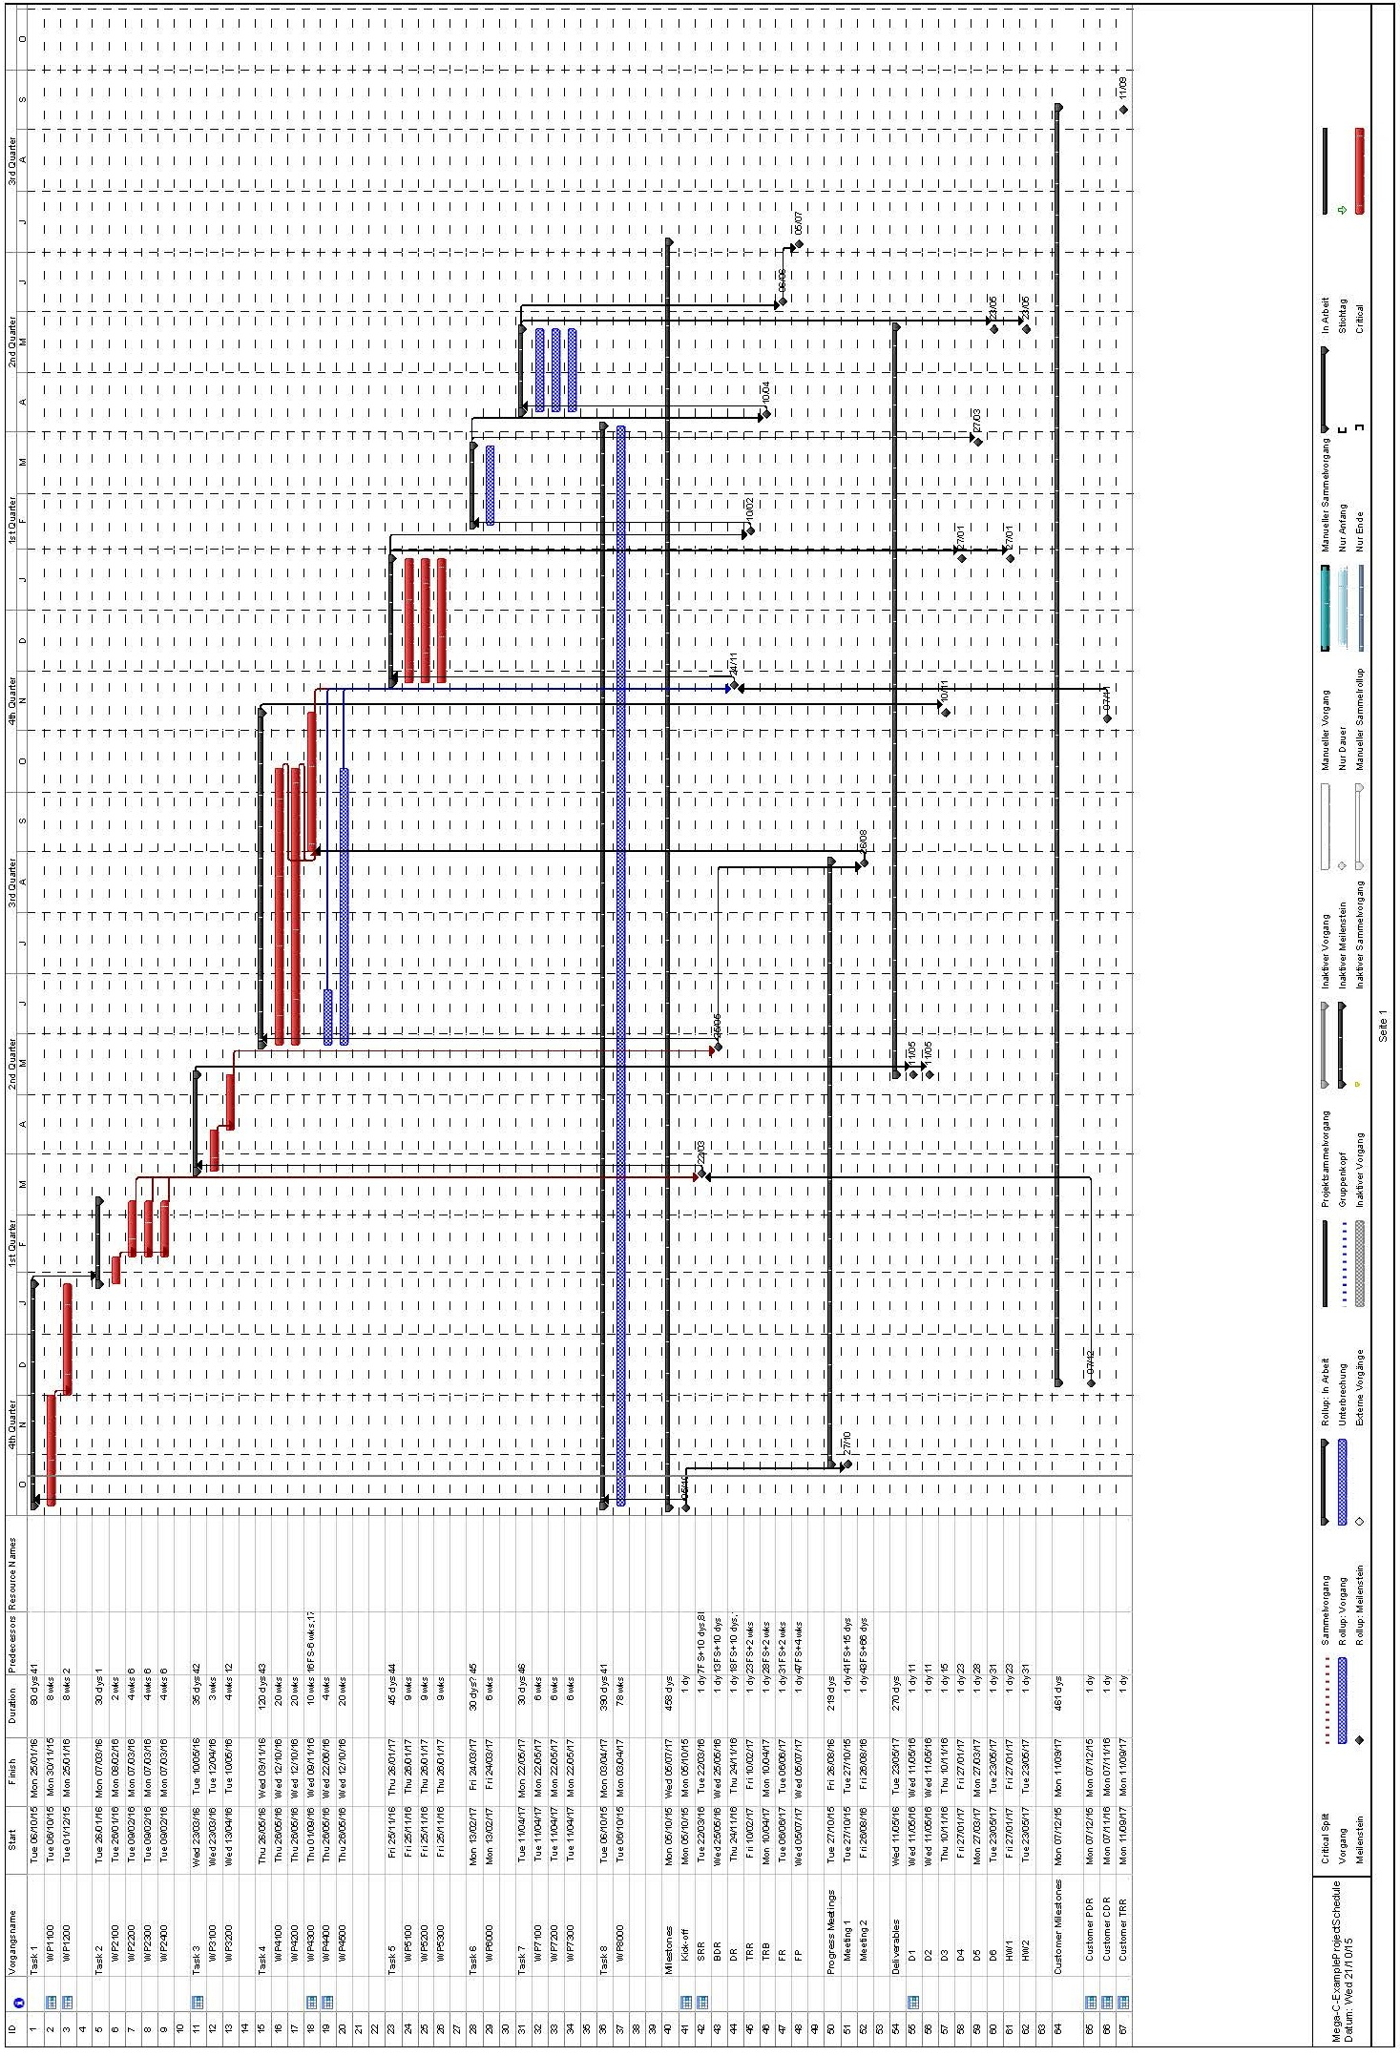

# Prior Work

This proposal does not include Prior Work.

or

This proposal includes Prior Work. The Prior Work is presented separately in Annex 2 with dedicated work packages, work package descriptions and complete work package outputs.

The work packages dedicated to the Prior Work are … (list the relevant work packages).

1. Work Package Descriptions

provide completed work package descriptions for each work package identified in the work breakdown structure

|  |  |
| --- | --- |
| PROJECT: … PHASE: … | WP: … |
| WP Title: …  Company: …  WP Manager: …  Start Event: … Planned Date: …  End Event: … Planned Date: … | Sheet … of …  Issue Ref …  Issue Date … |
| Inputs:  …  Tasks:  …  Outputs:  … | |

1. Work Package Descriptions (Prior Work)

*Include only if Prior Work is proposed*

*provide completed work package descriptions for each work package identified in the Prior Work*

|  |  |
| --- | --- |
| PROJECT: … PHASE: … | WP: … |
| WP Title: …  Company: …  WP Manager: …  Start Event: … Planned Date: …  End Event: … Planned Date: … | Sheet … of …  Issue Ref …  Issue Date … |
| Inputs:  …  Tasks:  …  Outputs:  … | |